Esports Code of conduct

Ethics and Codes of Conduct

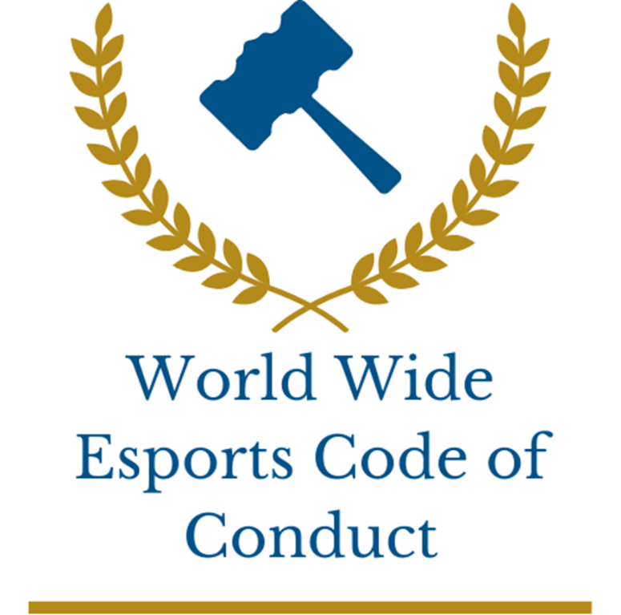

Abstract

This document is my representation of what a code of conduct in Esports should look like covering issues such as cheating, drug abuse, players mental and physical health and the consequences put in pace for infringements. This document also includes my commentary on the ethos, implementations, and obstacles I may face when implementing the code of conduct.

Table of Contents

Who we are: 2

Our values: 2

1 General rules: 3

2 Player and pro player rules: 3

3 Pro Players on LAN Rules: 4

4 Leagues/Tournament hosts: 5

5 Developers: 6

Appendix: 7

## Who we are:

Worldwide Esports Code of Conduct is a new regulatory body in Esports with the aim of creating stability and integrity by giving a code of conduct that covers all parties involved in the Esports scene.

Currently Worldwide Esports Code of Conduct has taken on the role of governing UK Esports encompassing players, pro players, pro players on LAN, league/tournament hosts and developers.

By putting these rules in place, it will make Esports more inviting for new players which can lead to new foundation for change such as more competitions for minority groups.

With this code of conduct league/tournament hosts have responsibility to make sure their tournaments are as prepared as possible against cheating, making Esports competitions more legitimate as there is less chance of people cheating.

## Our values:

Fair process – When an investigation in any form is going on its in our best interests to make sure the process is fair for both parties involved.

Justice – If a player or organisation is caught breaking the rules, we will make sure the penalty is appropriate and proportionate.

Respect – We as an organisation will respect everyone we interact with and will treat everyone the same, with this we also expect a level of respect from everyone and will not tolerate abuse to staff.

## 1 General rules:

Rules that apply to everyone who plays the games, makes the games, hosts tournaments for the games.

1.1: Harassment/Toxic behaviour in and out of game – all forms of harassment including racism, sexism, homophobia, transphobia and ableism are strictly prohibited.

1.2: Drug abuse - such as the use of performance enhancing drugs such as Adderall, amphetamines, marijuana, hashish, cannabis products, nadolol or acebutolol are not allowed unless properly prescribed a doctor.

1.3: Cheating - Cheating is not allowed and the use of software such as Aimbot, Wallhacks, No clip, Lag switch, Exploits, Dedox & look- ahead or other 3rd party software is strictly prohibited.

**Consequences:**

1.1 - Breaking (1.1) rule will lead to the player being banned from using all game chat options for 1 week. If they are found breaking the rule within a week after the ban, the ban will be increased to 2 weeks.

1.2 - Disobeying (1.2) rule will lead to a ban from all active tournaments and any future tournaments in the next 3 months. If the player is caught reoffending the ban will be increased to 12 months.

1.3 - If a player is caught using 3rd party software they will be instantly banned from the game and will not be able to compete in any tournaments for 1 year.

## 2 Player and pro player rules:

Pro Player rules are rules that will apply to players all playing the game.

2.1: Match fixing – No player who is partaking in a tournament should manipulate the match (throwing rounds) to earn money.

2.2: In game names (IGN) – IGNs must be appropriate so no profanity, racist, sexist, homophobic, transphobic, ableist names.

2.3: Player behaviour:

2.3.1: Text/voice chat – Text and Voice chat must not be used in a way that will ruin other players experience such as being racist, sexist, homophobic, transphobic or ableist.

2.3.2: Sabotaging games – Sabotaging games also includes throwing rounds, leaving the game (AFK), assisting the enemy team, intently feeding and friendly fire are all bad sportsmanship.

**Consequences:**

2.1 - Match fixing in any way will lead to an instant ban from tournaments for a year and a player committing a reoffence will be banned from all tournaments for 10 years.

2.2 - If a player IGN is inappropriate, they will be forced to change it to something more appropriate.

2.3.1 - Breaking this rule will lead to the player being banned from using in game chat or voice communication for 1 week. If they are found breaking the rule within a week after the ban, the ban will be increased to 2 weeks.

2.3.2 - If this rule is broken the payer will be give a ban from queueing into a game. 1st time getting caught will be a 5 minute ban 2nd will increase to 15 minutes and 3rd will increase again to 30 minutes any subsequent offence it will be 1 hour.

## 3 Pro Players on LAN Rules:

Pro players on LAN rules will apply to Pro players who are playing in tournaments in person (LAN).

3.1: Player behaviour - Players are respectful towards other players and staff so no swearing or being racist, sexist, homophobic, transphobic or ableist towards players or staff.

3.2: Communication - No phones, smart watches or devices that can be used to communicate should be brought onto stage by the players.

3.3: Coach time - Once the game starts players cannot communicate to coaches unless there is a pause, timeout or break between games.

**Consequences:**

3.1 - If a player is caught being disrespectful to staff or other players, they will be given a 1 game ban. If the player is caught again in that tournament or any other tournament for the next 3 months they will be banned from the tournament and any other tournaments for the next 6 months. They will also be given £2,000 fine for each instance.

3.2 - If a player is caught with a communication device, they will be given a 1 game ban. If the player is caught again in that tournament or any other tournament for the next 3 months they will be banned from the tournament and any other tournaments for the next 6 months.

3.3 - If players are communicating with the coaches or vice versa, outside of designated times e.g., during the matches, the team will be disqualified from the tournament. If they are caught again, the team will be banned from competing for a year.

## 4 Leagues/Tournament hosts:

Rules that apply to leagues/tournament hosts.

4.1: Handling drug abuse - It is the leagues/tournament hosts job to perform drug tests on every player at the event. Once a team has entered a tournament random drug testing must be consented leading up to the tournament and a test should be done on every player at the event.

4.2: betting:

4.2.1: Players/team - No players playing in the event can bet on any games in the tournament.

4.2.1: Staff - Any staff working on the event are not allowed to bet on any games in the tournament.

4.3: Substitutions - It is up to the leagues/tournament hosts how they want to run substitutions.

4.4: Equipment testing - It is the leagues/tournament hosts role to test player equipment to make sure there are no hacks installed on the hardware.

4.5: Cosmetics - With some games having skins or cosmetics that can give the player an advantage it is down to the leagues/tournament hosts to ban the skins or not.

4.6: Event accessibility:

4.6.1: Players - Events must be accessible for all players including wheelchair access and the country the event is held in.

4.6.2: Spectators - Events must be accessible for all spectators including wheelchair access and hidden disability’s, allow guide dogs, for big events headphones need to be given out with descriptions of what is happening in the game for blind people and auto-generated captions of what the casters are saying for deaf people.

4.7: Time between games - Time given to allow players to recover mentally and physically to not affect their physical and mental well-being after games are played.

4.8: Timing of the events - Players should be given 1-2 months to learn the new updates and adjust to the changes if an older patch can’t be used.

**Consequences:**

4.1 - If the league/tournament host decide to run drug tests if a player fails the test the player will be banned from the event and fined £1,000.

4.2.1 - If a player is caught betting the player will receive an instant ban from tournaments for a year.

4.2.2 - If a staff member is caught betting the staff member will be removed from their role from the rest of the event.

4.3 - Substitutions is decided by the league/tournament host however if a team Is caught breaking the rules the team will be banned from the event.

4.4 - If a player is caught with equipment that has failed the test the player will be banned from the event and will not be able to compete in any tournaments for 1 year.

4.5 - If a player is using a cosmetic that the league/tournament host has banned the game will be replayed.

4.6 - If the league/tournament host do not make their event accessible for both player and spectator the league/tournament host will be banned from running events till the issues are rectified.

4.7 - If time is not given to players to mentally and physically recover after games the league/tournament host will be fined £20,000.

4.8 – If the tournament ends up running over a patch update the matches will have to be played at a later date.

## 5 Developers:

Rules that apply to developers creating games.

5.1: Bugs - If game breaking bugs are found that give one team a competitive advantage over the other it’s the developers role fix the bug before big events or as soon as possible.

5.2: Accessibility - Games that are made must be accessible to everyone. This means they must include subitise as an option, colour-blind modes, language translation and changing input layout (e.g., keyboard layout).

5.3: Mental health - Games being made must have an option to allow the player to limit the time they spend on the game.

**Consequences:**

5.1 - If a game breaking bug is found and cannot be fixed before big events the developer must produce an illustrated description of the bug so league/tournament hosts can identify if a player is using the bug to gain an advantage. If this does not happen, they will be fined £10,000.

5.2 - If a game is not made to be accessible the game will need to be taken down until changes are made.

5.3 - If the game does not have an option to allow the player to put a time limit on the game will be taken down till changes are made.

## Appendix:

LAN - Local area network also know as LAN is when a competition is run over the same internet or in the same room which means no one has a disadvantage with connection in game.

Match fixing - Is when a player intently loses a game typically gaining a reward such as money or skins (that can be sold for money). This can involve someone asking them to deliberately lose so they can earn money through betting (one of the main ways to earn money with match fixing) and splitting the money with the player or team.

Bugs - Bugs are unintentional issues that a game might have such as not being able to do a certain mechanic in game or being able to do something that should not be done. This can sometimes give players a competitive advantage.

3rd party software - Is software download onto the computer that will give the player in game a competitive advantage such as Aimbot which gives the player inhuman flicking ability. Another example is wallhacks where the player can see through walls so know where the enemies are always.

Patch updates - When a game has changes made that can change the game dramatically such as character or map changes. That will overall affect how the game may be played or strategized.

In game chat options – These are ways players can communicate with one another such as voice chat and text chat.