Are there opportunities for disabled/impaired gamers in esports?

Intro
According to the Equality Act 2010 you are disabled if you have a physical or mental impairment that has a ‘substantial’ and ‘long-term’ negative effect on your ability to do normal daily activities.” (GOV.UK). ‘Substantial’ means it takes the person longer than it usually would to complete daily tasks such as getting dressed, while ‘long-term’ would mean 12 months or more such as a breathing condition that develops from a lung infection (GOV.UK). Latest statistics reveal that in 2021 “14.6 million people in the UK had a disability which represents 22% of the total population” (UK Parliament, 2022). These facts demonstrate a need to consider how esports should respond to this growing demographic and perhaps more importantly, what opportunities and disadvantages disabled gamers face in esports.

This assignment, exploring recent evidence, will therefore investigate if the opportunities for disabled or impaired gamers outweigh the Issues and constraints for them, as well as looking at future possibilities. The many distinct aspects of opportunities such as adaptive controllers, in-game settings and the rehabilitation side will be explored. These negative aspects, including claims of unfair advantage, and a lack of tournaments, will also be examined. This essay will conclude that although there are opportunities for casual gaming, the issues and constraints are far greater for gamers with a disability/impairment to become a professional gamer. Before examining the opportunities for disabled/impaired gamers and the issues they and esports face I will begin by briefly exploring what esports is and how they have supported players with disabilities.

Context
British Esports defines esports “as competitive video gaming where skill and professionalism is celebrated. The pro gamers who play at this level know the games inside out, much like a professional footballer or athlete would in their respective fields.” (British Esports, 2016). Furthermore, it is a way for players to express themselves as well as give them an opportunity to do something they enjoy for a living. For example, “in 2022 the global esports market was valued at just over 1.38 billion U.S dollars.” (Gough, 2022). Moreover, it also allows players to showcase their skills in gaming and be part of many communities.
With the popularity of esports increasing it could be argued that the industry has been slow to adapt to the needs of people with disabilities, despite the rise in accessibility enabling those who are disabled to play sports and other leisure activities. It could be argued that the concept of ableism is more prominent in esports. Ableism is defined as the view that if a person has a disability, it means they are inferior and are incapable of taking part in mainstream activities. This has been seen in different industries including esports. However, with a recent increase of charities and organisations which are promoting accessibility, such as Sport England and Disability Rights UK, there is greater inclusion for those with disabilities. Creating greater opportunities for those with disabilities is now being addressed in esports, albeit at a slow pace.

Opportunities for people with disabilities
One way that esports is being more inviting for players with a disability are adaptive controllers. Controllers are devices used to control what is happening in a game. Adaptive controllers are designed to be used by people with disabilities as they can be adjusted and changed to help gamers with disabilities play.
Microsoft (Xbox) is currently one of the leading examples of an organisation wanting to help people with disabilities get into esports. This has been done by creating a controller specifically designed for people who may need bigger buttons or extra buttons pugged in such as foot pedals or joysticks. Spencer Allen notes “The Xbox Adaptive Controller allows users to connect switches, buttons, joysticks and mounts to create a custom controller that suits their needs and abilities” (Microsoft XBOX, n.d).
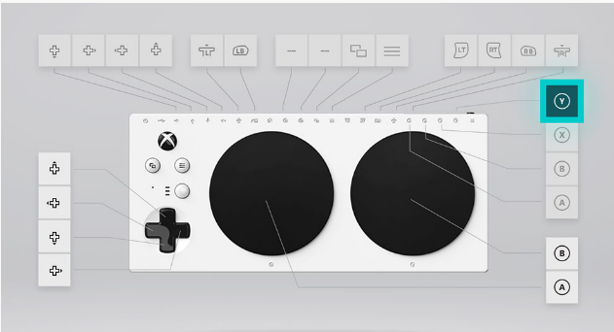
Image 1 Microsoft XBOX adaptive controller features (Microsoft XBOX, n.d)
Therefore, this allows the controller to accommodate a larger range of disabilities thus allowing more people to participate in gaming as they are able to create a personal controller just for their needs. Furthermore, the Xbox adaptive controller is significantly cheaper costing just £74.99 (Microsoft store Inc. VAT). This gives the added advantage of being more affordable for those with disabilities.
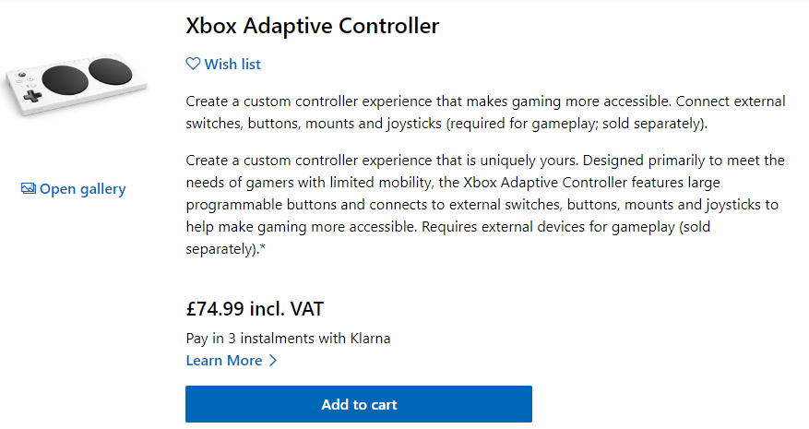
Image 2 Microsoft XBOX adaptive controller (Microsoft XBOX, n.d)
PlayStation introduced project Leonardo in January 2023: “Project Leonardo for PS5 is a canvas for gamers to craft their own play experience. It includes a robust kit of swappable components, including a variety of analog stick caps and buttons in different shapes and sizes.” (Nishino, 2023). This is very significant as it adds a new competitor into the adaptive controller industry but, also shows the esports industry there are gamers with disabilities in esports and game developers may start to work with Xbox and PlayStation to make sure their adaptive controllers work with their game which will make more games accessible.
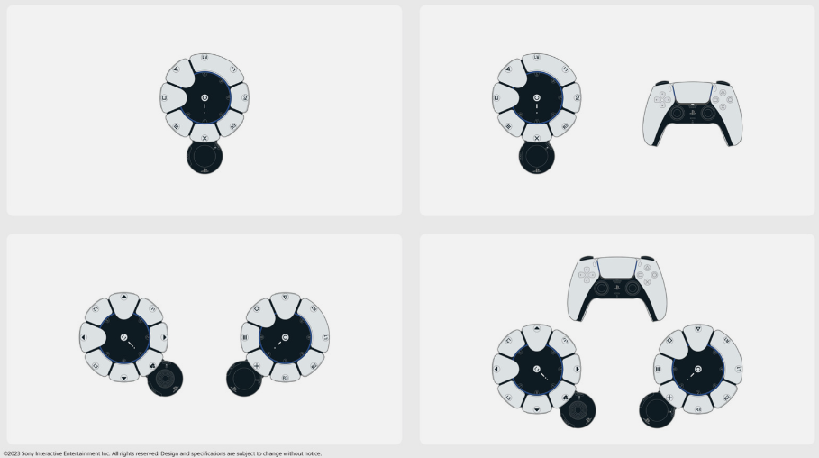
Image 3 different ways of using project Leonardo (Nishino, 2023)

Quadstick is another company innovating in the gaming controller industry with their hands-free controller. This controller has enabled many gamers with disabilities to enjoy playing their favourite video games as seen below which demonstrates the vast amount of people using the Quadstick across the world.
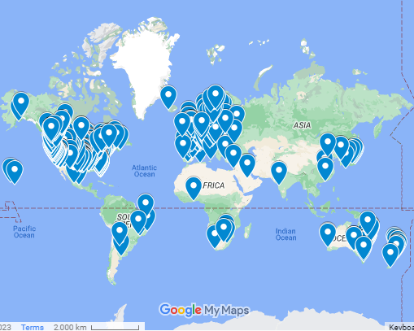
Image 4 Quadstick users around the world map date 2023 (Quadstick, 2023)
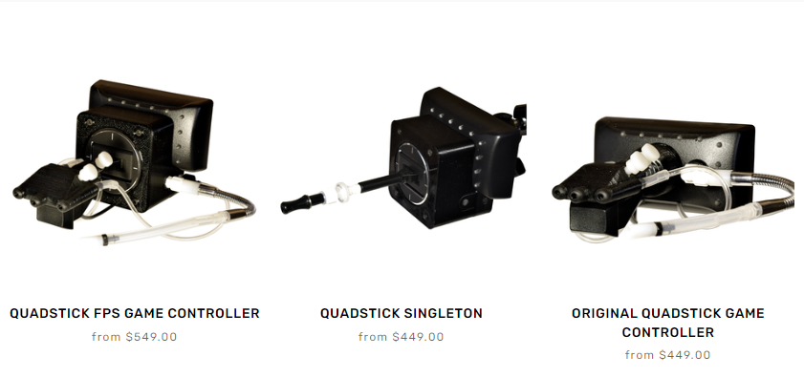
Image 5 Quadstick controllers (Quadstick, n.d.)

One group of world-class disabled gamers which use the Quadstick controller, go by the title the “Quad gods”. As discussed in an article for the BBC (Adeane, 2021), one of the “Quad gods”, Chris Scott, was paralysed from the neck down, following a skydiving accident. Dr David Putrino was exploring different ways of improving patient health. When he met Scott, he asked him what he likes to do, and Scott told him he loved playing video games. So, Dr Putrino loaded up a game called NBA 2K and connected a Quadstick which allowed Scott to play games using his mouth. Scott and Dr Putrino decided to create an Esports team with other quadriplegic players.
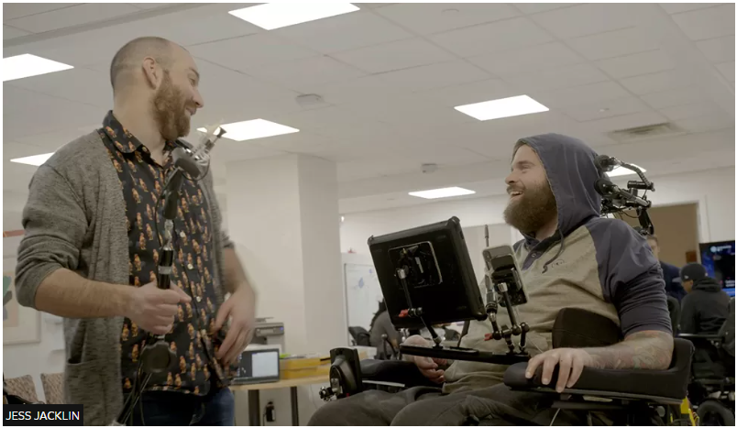
Image 6 Picture of Dr David Putrino and Scott (BBC, 2021)

Scott sent out a message to the other patients at the hospital and created a group that would enter tournaments. Sadly Scott died of a chest infection, but the team decided to carry on and go by the name ‘Quad gods’. In the first competition they played out of 99 teams. Whilst hoping to finish in the top half they were in fact hugely successful by coming 4th. Quad gods achievements began to increase as they started winning more tournaments online with huge success in Fortnite, a popular fighting game. (Adeane, 2021). This group of individuals put aside their disability and used their adaptive controllers to win esports events thus proving that having a disability does not mean you cannot play video games but that you can even win tournaments.

Another example of opportunities that allow people with disabilities to play video games is the adaptions which can be made in the game settings. Games settings can be changed to allow those with a wider range of disabilities enjoy games such as colour-blind mode, subtitles for deaf people and, input changes to allow extra buttons to be added such as foot pedals. All these help people with disabilities be able to play the games.
Fortnite is a notable example of a company pushing the boundaries of allowing non-abled people to enjoy playing video games. This has been done through advanced settings such as colour-blind mode (now found in most games) as well as visualised sound which allows deaf people to see on their screen sounds that are around them. This was revolutionary and although has not been picked up by other games, it has allowed deaf players to play the game.
‘Can I play that?’ is a website that covers accessibility in the esports industry including games and controllers. For example, Fortnite was rated 10/10 with the visualised sound setting and ability to add subtitles and customise them: “There’s visualization for every essential sound in the game too. There’s visualization for treasure chests, visualization for footsteps/running, visualization for gunfire. And it all tells you the approximate direction and distance too, along with icons and colors unique to each sound type.” (Deaf Game Review – Fortnite, Can I play that? 2020)
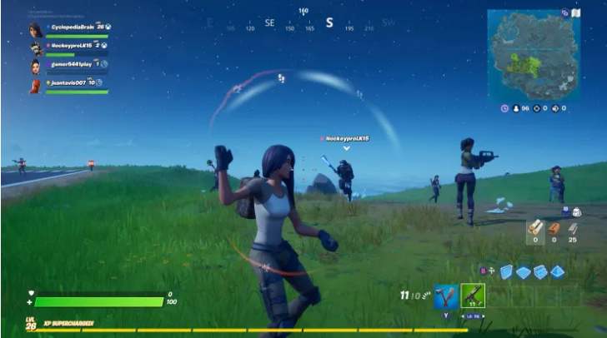
Image 7 screen shot showing off the visualise sound setting in Fortnite (can I play that?, 2022)

Lastly esports and gaming can be used for rehabilitation. For example, the AbleGamers charity was set up to help people with disabilities get into gaming. The benefits being that esports will “help address social isolation, be the home of inclusive communities and improve the quality of life for people with disabilities.” (Our Impact, AbleGamers,2022)
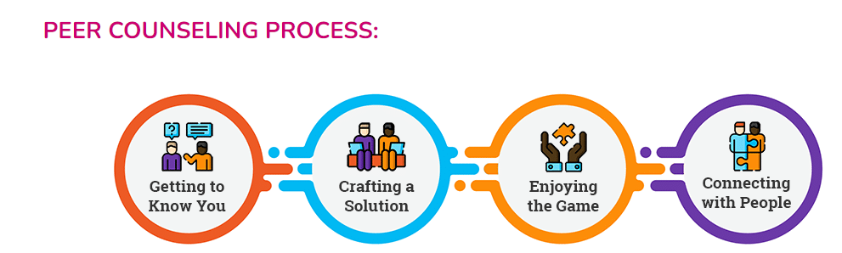
Image 8 visualisation of the peer counselling process (peer Counselling, AbleGamers, 2022)

The AbleGamers charity achieve this by having a peer counselling process. According to AbleGamers this is where they: “invite the player to lead the session(s), to share with us the experience they seek and their goals. We help to uncover a player’s strengths (and challenges) so that we can lead them down a path of success.” (Peer Counselling, The AbleGamer charity, 2022.). This is important as it builds a relationship with the player and an understanding of what they need.
Next, they “get to know the environment and the resources at their disposal. We work toward individualized solutions that will allow the player to start playing.” (Peer Counselling, The AbleGamer charity, 2022.). This means the player is guaranteed to have a custom setup that works for them, which is vital because for a person to enjoy playing games they must be comfortable.
Then they “lead players into rich social communities to explore amazing worlds and stories, combat social isolation, and join millions of players worldwide” (Peer Counselling, The AbleGamer charity, 2022.). This gives the player a starting point allowing them to have supportive people around them to help start off in gaming.
Furthermore, the AbleGamers charity also have 3D printers and access to industry partners if a specific part needs to be made. AbleGamers write “when we have a solution to build for players, the AbleGamers Centre for Inclusive Play in Kearneysville, WV has a state-of-the-art maker space that includes 3D printers, laser, and electronics manufacturing facilities on site. We combine custom-built components with commercial products to create robust, individualized solutions that help get players past the initial barriers to play and into the game” (Engineering research, The AbleGamer charity, 2022). Once this is achieved, they argue that they lead the player into social communities which combat social isolation. (Kody, The AbleGamer charity, 2022)
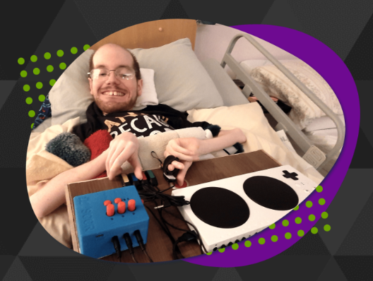
Image 9 Kody at his adaptive setup (Kody, AbleGamers, 2022)
An example of someone they helped is Kody, who was born with Spinal Muscular Atrophy. Kody wanted to have a gaming environment that was not only comfortable but also effective. Through many virtual meetings he would show his personal findings at sessions where numerous tests were performed including the Xbox adaptive controller. After a few weeks, the setup was a huge benefit to Kody’s gaming. For example, Kody told his AbleGamers peer counsellor Aaron “I have been using the alt controller with great success. It works well.” (Kody, The AbleGamer charity,2022).
Despite this marked improvement for Kody, the charity commented that he “was still limited to the games he could play so AbleGamers purchased an eye tracker and gifted it to him. This made it easier to do tasks such as sending emails and has been used to play games alongside the alt controller.” (Kody, The AbleGamer charity,2022). Thus “he admitted that there has been challenging times but has worked through them and is really enjoying it.” (Kody, The AbleGamer charity, 2022).
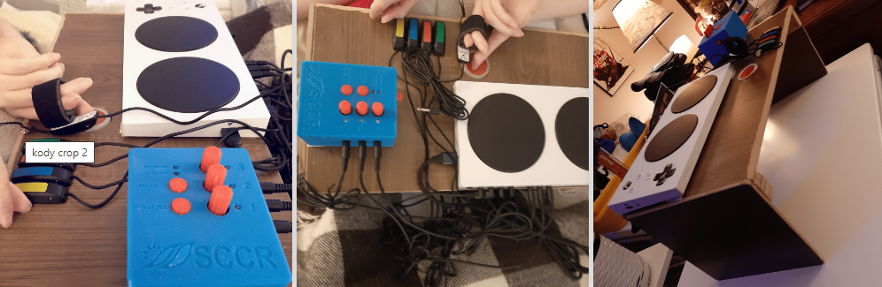
Image 9 Kody’s adaptive setup (Kody, AbleGamers, 2022)
The AbleGamer charity has proved that even with a disability anyone can play and be fully involved with electronic games. Furthermore, they have made an enormous impact to making gaming accessible for those with disabilities by helping “thousands of people with disabilities through Peer Counselling and assistance with hardware and software challenges.” (Our impact, The AbleGamer charity,2022)
Whilst there has been much to aid the inclusion of those with disabilities to play esports there are issues and constraints for people with disabilities. These will now be discussed.

Issues and constraints for people with disabilities
It needs to be acknowledged that disabilities can be very different and therefore recognised that not everyone with a disability can use the same adaptive controller such as the relatively cheap Xbox adaptive controller. There is not a one size fits all solution. Some people may require the Xbox adaptive controller and five more buttons, joy cons or foot pedals. All this can add to the cost thus making it harder for people with disabilities to get involved. For example, if a disability results in the person being unable to press any buttons and instead requires them to having to use their mouth. For that person to participate in esports they would need to potentially purchase a mouth controller from Quadstick. As previously discussed Quadsticks are extremely inclusive, allowing those with disabilities to play esports successfully, however they can be costly (this could easily end up costing in excess of $500). This increase in cost could potentially deter those with a disability from participating in esports.
A further cost to be incurred could be travelling expense when going to events. It may cost the person more to bring the extra adaptive gear with them as well as paying for carers to travel with them. When flying to events if the person has a wheelchair there is the risk that it may get damaged, lost or broken. For example, a famous disabled street fighter who goes by Brolylegs said "every time I've gone on a flight, [the chair] comes back a little more broken than I left it," (Teng, 2019). Moreover, for a disabled esports athlete, if any of their gear breaks it could be difficult to repair or replace especially if it is a custom design just for them. It could also rule them out of the tournament so not only are they not able to play but they must then repair their gear. This is especially off putting for disabled esports athletes from a lower economic household who may not be able to cover the costs of repairing broken gear.

Another issue that those with disabilities face could be potential claims of unfair advantage. It should be noted that having an advantage is not the same issue as an unfair advantage. An unfair advantage is when one of the players competing in a tournament would be at a significant disadvantage. This not only has implications for the players, such as the match being uncomfortable and a lack of enjoyment for the players but also effects those watching the game with a potential lack of excitement.
Claims of unfair advantage could be an issue that gamers in esports with a disability may face. This is because there are many different disabilities that each have their own solution to allow them to play. If this is unregulated it may become unfair if someone is destroying the competition. AbleGamers Charity COO Steven Spohn writes, “you’re not going to make a competition fair between someone who can barely push the buttons on a standard controller or someone who needs a specialty controller versus someone who is an absolute monster at Fortnite” (Duran, 2020).
Adaptive controllers play a role in this issue, as there is no standardised controller as discussed before the Xbox adaptive controller can be changed in many ways this means one player can have 3 extra buttons while another may need 6. This makes it challenging to run tournaments as one player may have a larger advantage over the other.
There is also the risk that if a gamer with a disability gets an assistance in the game that allows them to destroy the competition. This may be the reason that currently there are not that many tournaments for gamers with disabilities.
For the esports industry to make tournaments less exclusive they would need to develop a system that allows everyone to play while being fair. By having tournaments for gamers with a disability it would solve many of the current problems, the main one being unfair advantage some gamers may have over others. One way to counteract this would be to have bracket systems in place (this is where players will be grouped up against similar players), so no one is at any disadvantage.

The final issue gamers with disabilities face is the lack of infrastructure to progress from casual to professional. For example, in Indonesia to counter this problem they set up the Esports Ability Indonesia (EAI). The EAI, established in March 2019, was “formed to provide a platform to help gamers with different abilities (disabled) have equal opportunities to compete with other gamers. As one of the founders, Shena Septiani’s perspective is quite similar to most non-disabled people who rarely interact with people with disabilities.” (Dinanyah, 2022, p.74). This means gamers with disabilities have a place to be able to go and get advice, play against other gamers and have the right backing to become an elite professional.
This was because “Previously, gamers with disabilities had informal groups gathered to play games. Still, the lack of organisation made it difficult for would-be gamers with different abilities to transition from a casual gaming setting to a competitive environment. The main challenges identified from the interviews were lack of access to information about competition and communication difficulties. These challenges can be overcome with the presence of EAI, as they can send one or two teams to monthly tournaments and receive funding from sponsors.” (Dinanyah, 2022, p.74).
This lack of infrastructure around the world for disabled gamers could be stopping more disabled gamers getting into esports which could be what the industry needs to push forward more events for those gamers.

Conclusion
In conclusion, whilst there are increasing opportunities for disabled gamers there are many barriers for them to compete in tournaments, making it harder for this to become their career.
The opportunities discussed are having a positive impact for more people with disabilities to play esports. With the launch of PlayStation project Leonardo, it has put a much needed spotlight on disability in esports and will get more people on board to make the necessary changes to make sure everyone is involved.
Considering how many people there are with a disability alongside how big esports is I believe there is a large constraint for disabled gamers worldwide who are trying to go professional. This is largely due to the many difficulties that are faced when regulating an esports tournament for people with disabilities. Unfortunately, this has resulted in esports putting disabled tournaments to one side. If a disabled player currently wants to compete, they might have to go against an abled body player which results in unfairness. However, this also has its own challenges such as access to the event and if they will be well accommodated for.
In summary, the evidence presented in this essay shows that esports has the opportunity to be forward thinking when it comes to facilitating those with disabilities. One way of doing this, which I believe would be greatly beneficial is to have more esports organisations such the EAI in other countries. This would not only help put different players into brackets which would help tournament organisers set up events, but more importantly create a structure that could allow casual gamers with disability’s achieve their dream of going pro.

Bibliography
Adeane, A. (2021) ‘Quad Gods: The world-class gamers who play with their mouths’, BBC, 29 January. Available at: https://www.bbc.co.uk/news/stories-55811621 (Accessed: 18 January 2023).
British Esports (2016). What are esports? An overview for non-fans. Available at: https://britishesports.org/general-esports-info/what-are-esports-an-overview-for-non-fans/#:~:text=An%20overview%20for%20non%2Dfans,-Published%3A%20December%206&text=Esports%20(or%20electronic%20sports)%20is,to%20it%2C%20like%20traditional%20sports. (Accessed 18 January 2023).
Deaf Game Review – Fortnite (2020). Can I Play That?Available at: https://caniplaythat.com/2020/02/21/deaf-game-review-fortnite/ (Accessed: 18 January 2023).
Dinansyah, F. et al. (2022). The Role of Esports Organisations in Accessibility for Disability Players. Ultimacomm: Jurnal Ilmu Komunikasi 14(1). pp.67-79
Duran (2020). Opinion: Esports inclusivity for disabled gamers begins in School. Esports insider. Available at: https://esportsinsider.com/2020/07/esports-inclusivity-disabled (Accessed: 18 January 2023).
Engineering Research. (2022). The AbleGamers Charity. Available at: https://ablegamers.org/engineering-research-2/ (Accessed: 18 January 2023).
Equality Act 2010. GOV.UK. Available at: https://www.gov.uk/definition-of-disability-under-equality-act-2010 (Accessed: 18 January 2023).
Gough (2022). Global eSports market revenue 2025. Available at: https://www.statista.com/statistics/490522/global-esports-market-revenue/ (Accessed: 18 January 2023).
Kody (2022). The AbleGamers Charity. Available at: https://ablegamers.org/impact/kody-r/ (Accessed: 18 January 2023).
Microsoft XBOX (n,d). Meet Spencer Allen. Available at: https://www.xbox.com/en-GB/community/player-spotlight/spencer (Accessed: 18 January 2023).
Nishino, H (2023) Introducing Project Leonardo for PlayStation 5, a highly customizable accessibility controller kit, PlayStation.Blog. Available at: https://blog.playstation.com/2023/01/04/introducing-project-leonardo-for-playstation-5-a-highly-customizable-accessibility-controller-kit/ (Accessed: 18 January 2023).
Our Impact (2022). The AbleGamers Charity. Available at: https://ablegamers.org/impact/ (Accessed: 18 January 2023).
Peer Counselling (2022). The AbleGamers Charity. Available at: https://ablegamers.org/peer-counseling/ (Accessed: 18 January 2023).
Teng, E. (2019) Meet Mike ‘Brolylegs’ Begum: A most extraordinary Street Fighter competitor, ESPN. Available at: https://www.espn.com/esports/story/_/id/27114444/mike-brolylegs-begum-most-extraordinary-street-fighter-competitor (Accessed: 18 January 2023).
UK Parliament (2022). UK Disability statistics: Prevalence and life experiences. House of Commons Library.Available at: https://commonslibrary.parliament.uk/research-briefings/cbp-9602/ (Accessed: 18 January 2023).

